DARRELL'S TAVERN PRESENTS A COLOSSAL ROCK-N- ROLL EXTRAVAGANZA!!

**SUGAR BURGER**

**RECOVERY BALL**

**PEEPING TOMBOYS**

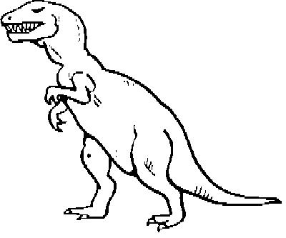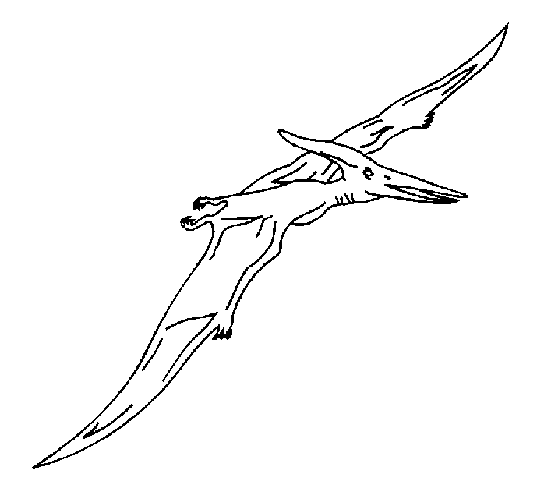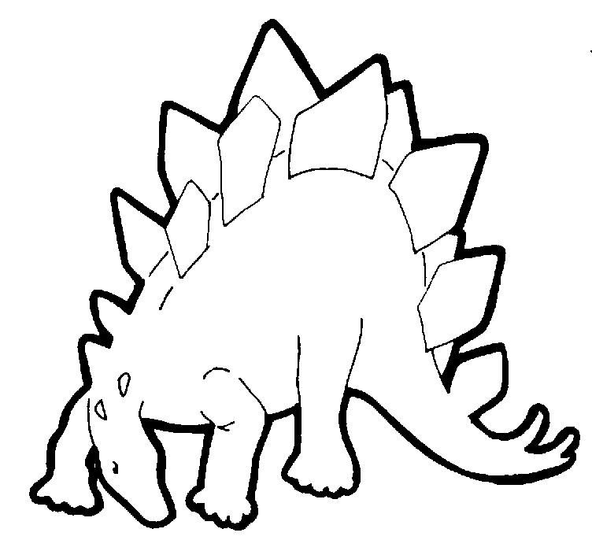

A ROCK-N-ROLL SHOW FOR THE AGES - oNLY 6 BUCKS!

**Saturday Nov 24th 9 PM**



**DARRELL'S TAVERN**

**18041 Aurora Avenue N**

